Tab 1

### Analyzing Employee Experience Survey Data

* AIM : Gaining insights into how employees feel about different aspects of their job

Descriptive statistics:

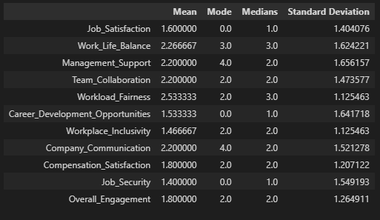

Fig.1

| columns | MEAN | MEDIAN | MODE | SD |
| --- | --- | --- | --- | --- |
| Job Satisfaction | lean towards dissatisfaction | common response is dissatisfaction | Half of the responses are below or equal to 1 | Responses vary, but the concentration is around dissatisfaction |
| Work-Life Balance | Employees are neutral | Employees are neutral | Half of the responses fall in the neutral range | High variation |
| Career Development Opportunities | Generally dissatisfied | common response is dissatisfaction | Strong dissatisfaction | High variation |

As we can see that most of the fields of the data set are going towards the dis-satisfaction.The high standard deviations suggest varied experiences among employees.So, their is a need to Focus on improving Job Satisfaction, Career Development Opportunities, and Workplace Inclusivity, as these show the highest dissatisfaction rates.

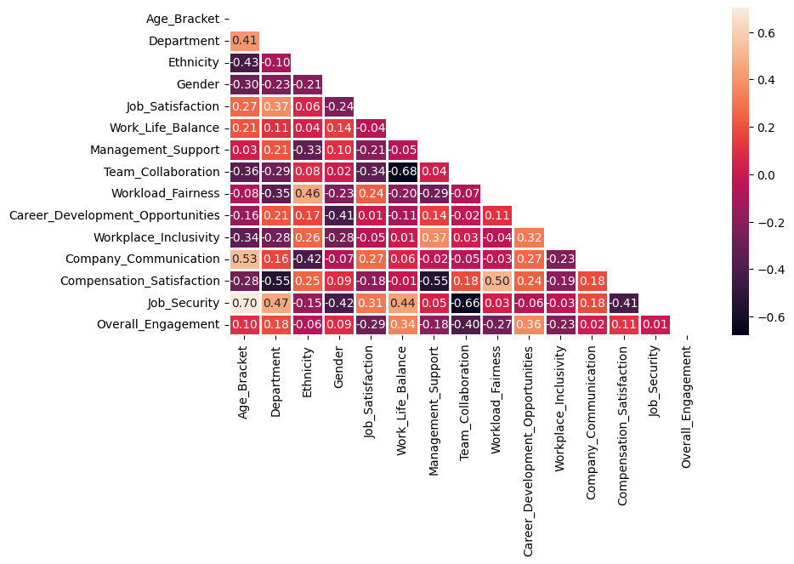

Fig.2

### Interpretation:

1. **Strong Positive Correlations (Light Orange)**:
   * **Example**: If workload fairness and compensation satisfaction are light orange, it indicates a strong positive relationship.
   * **Insight**: Employees who perceive their workload as fair are also likely to be satisfied with their compensation.
2. **Strong Negative Correlations (Dark Purple)**:
   * **Example**: If compensation satisfaction and job security are dark purple, it suggests that as job satisfaction decreases, perceptions of workload fairness also decline.
   * **Insight**: As compensation satisfaction decreases, job security perceptions also tend to decrease.
3. **Weak or No Correlation (Colors closer to the middle of the scale)**:
   * **Example**: If Age Bracket and Management Support show colors around the middle, it indicates little to no correlation.
   * **Insight**: Age may not significantly impact perceptions of management support.

Visualization

### Work-Life Balance:

Fig.3

* **Satisfied (60%)**: A majority of employees report being satisfied with their work-life balance.

**Insight**: certain policies from upper management such as work from home ,flexible work hours, holidays etc might be effective for maximum employees.

* **Not Satisfied (33.3%)**: A significant portion of employees feel not satisfied.

**Insight**: employees might be suffering from work overload , lack of holidays , maximum work hours.

* **Neutral(6.6%)**: A small percentage of employees are neutral

**Insight**: there might be a need for slight adjustments or additional support from the management team.

### Team Collaboration:

Fig.4

* **Satisfied (33.3%)**: Only a third of employees feel satisfied with team collaboration.
  + **Insight**: There are mixed feelings about team dynamics or communication.
* **Neutral (33.3%)**: Another third is indifferent, which might indicate variability in team experiences.
  + **Insight**: Enhancing communication between the team members or team-building activities might help employees to feel satisfied.
* **Not Satisfied (33.3%)**: A third of employees are not satisfied with team collaboration.
  + **Insight**: this suggests that there is lack of teamwork, team communication and moral support for the employees.
* Task:Are employees in a certain age bracket or department more satisfied than others?

Fig.5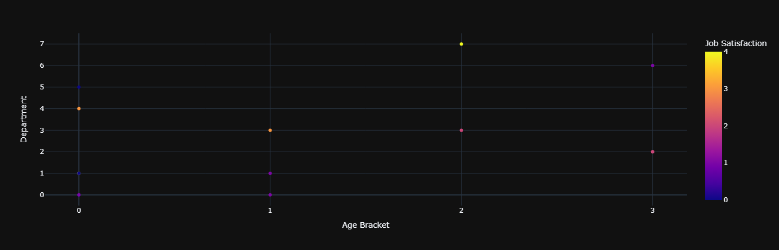

* Younger Employees (18-24): More variability in job satisfaction, with experiences ranging widely.
* Older Employees (45-54): Generally higher job satisfaction, indicating more stability or satisfaction in their roles.
* Task:Does any demographic group (age, gender, ethnicity) show patterns in certain areas (e.g., Work-Life Balance or Compensation Satisfaction)?

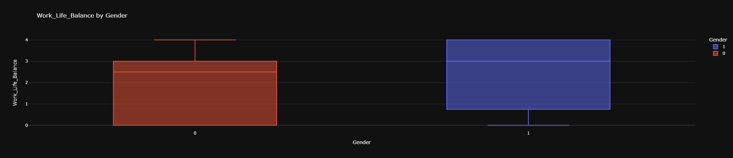

Fig.6

* Gender Differences:
* Gender 0: Generally lower satisfaction with Work-Life Balance.
* Gender 1: Generally higher satisfaction with Work-Life Balance.
* Insights:
* Implement certain programs or we can organize a feedback program to know about the factors leading to the lower Work-Life Balance satisfaction among Gender 0.
* Continue supporting practices that contribute to higher satisfaction among Gender 1.

CONCLUSION:

Our investigation led us to the conclusion that numerous new rules are necessary to address issues including job happiness, work-life balance, workplace inclusivity, job security, and general involvement.We must create specific policies and engagement initiatives for younger employees in order to ensure their sense of security and job happiness.

Men dispute the idea that there is a work-life balance, whereas women concur. This suggests that the man needs focused assistance to enhance his work-life balance.

The evenly divided satisfaction scores point to the need for better communication and team relations.Collaboration within the team can be increased by planning team-building exercises and improving communication resources.

A particular age group has demonstrated a higher level of satisfaction with certain areas, such as sales and HR.Therefore, we must apply the policies that are in place in these departments to other areas where there is a low level of satisfaction.

Since feelings of job insecurity are linked to wage dissatisfaction, addressing compensation-related issues could improve perceptions of work security.And workers believe that the workload is split equally among everyone.

Implement programs for younger employees' career development to raise their engagement and job satisfaction.Conduct regular compensation reviews to ensure competitive and fair pay, which can help improve job security perceptions.To enhance team dynamics and collaboration, plan frequent team-building exercises and promote open communication.Sustain and expand over approaches that help senior workers feel more satisfied with their jobs, and replicate these effective practices to other department.